**International Technology**

**Q. what is an Engineers and its work ?**

* Engineers, as practitioners of engineering, are professionals who invent, design, analyze, build and test machines, complex systems, structures, gadgets and materials to fulfill functional objectives and requirements while considering the limitations imposed by practicality, regulation, safety and cost.
* Engineers work in a variety of settings, according to Live Science, including construction sites, refineries, industrial facilities, nuclear power plants, and research laboratories.



6 Types of Engineers

* Chemical Engineer
* Civil Engineer
* Electrical Engineer
* Mechanical Engineer
* Aerospace Engineer
* Production Engineer

Preparing for a career Engineering

Other Types of Engineering Career



**1. Chemical Engineer**

Chemical engineers apply key principles of mathematics, biology, chemistry, and physics to create and manufacture various products. Whereas some professionals in the field work at refineries to transform crude oil into products such as asphalt, heating oil, gasoline, and lubricating oil, others work at companies that convert other raw materials, such as beeswax, into candles, home and body creams, and furniture polish.

-Although some job duties for chemical engineers, such as estimating production costs, are uniform across the field, others can vary widely depending on the company. Common daily duties may include:

* Conducting tests and monitoring the performance of various processes
* Troubleshooting problems that arise in the manufacturing process
* Developing methodologies for separating components in gasses and liquids
* Conducting research designed to improve manufacturing processes

Most chemical engineers work full time, Monday through Friday, in laboratories or offices. Some professionals in the field travel to visit plants and worksites.

**2. Civil Engineer**

Civil engineers conceptualize, build, and design infrastructure projects such as roadways, airports, tunnels, and water and sewage plants. Some professionals work directly with state and local government agencies, while others work with construction or engineering firms.

Civil engineers’ job duties can vary widely depending on their area of specialization. They might specialize in earthquake engineering, highway engineering, traffic engineering, architectural engineering, or fire protection engineering, for example. Whichever area a professional specializes in, common duties may include the following:

* Surveying reports and analyzing long-term plans
* Evaluating project and construction costs
* Evaluating potential environmental hazards and the potential environmental impact of each project
* Overseeing the maintenance and repair of public and private infrastructure projects

Most civil engineers work full time, Monday through Friday, in office settings. However, some professionals travel to visit construction sites to troubleshoot problems.

**3. Electrical Engineer**

Electrical engineers design and test various types of electrical equipment, such as power generation systems, electric motors, and electrical equipment. Professionals in this field often work with a wide variety of electrical equipment, such as radar and navigation systems, wiring for commercial and residential buildings, and computer circuit boards. Although the day-to-day responsibilities of electrical engineers can vary widely, common duties include the following:

* Designing and implementing new ways to use electrical power
* Directing and overseeing the manufacture, testing, and installation of electrical equipment
* Working with project managers to ensure projects are completed correctly, on time, and on budget
* Performing calculations to ensure construction and manufacturing standards are met

Most professionals in this field work full time, Monday through Friday, in office settings. However, they may travel to construction sites to help resolve problems.

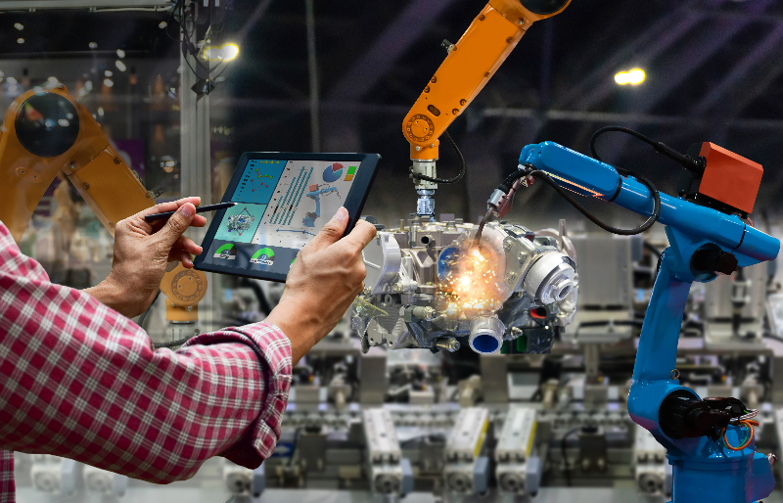**4. Mechanical Engineer**

Mechanical engineers design, develop, and test a variety of mechanical devices, such as sports and sound equipment, microsensors, robots, car engines, and manufacturing equipment. Whereas some professionals in this field work with small companies or startups, others work with major global corporations. Industries that hire mechanical engineers include health and medicine, air and space, robotics and manufacturing, and transportation and infrastructure.

The day-to-day responsibilities of a mechanical engineer can vary significantly depending on their industry; however, common duties often include the following:

* Developing and testing prototypes of their designs
* Analyzing problems to determine which types of mechanical devices could be used to solve each problem
* Analyzing test results and making changes to designs as needed
* Overseeing devices’ manufacturing processes to ensure design specs are being followed

Most mechanical engineers work full time in office settings, although some may travel to worksites to work on malfunctioning equipment.

**5. Aerospace Engineer**

Aerospace engineers are primarily concerned with designing, developing, and producing aircraft and spacecraft, national defense systems, satellites, and missiles. Whereas some professionals in this field specialize in a specific product, such as military fighter jets, others specialize in areas such as navigation and control systems. Most aerospace engineers are employed by aerospace and parts manufacturing companies, engineering firms, and the federal government.

Although the exact duties of professionals in this field can vary widely depending on their specialization, common duties may include the following:

* Ensuring each project meets quality standards
* Determining whether each proposed project meets its defined goals and will result in safe operations
* Coordinating and directing the design, testing, and manufacture of aerospace and aircraft products
* Inspecting damaged or malfunctioning equipment to identify the cause of, and solutions for, various problems

Aerospace engineers often work full time in office settings, although some professionals in the field may need to work overtime hours to ensure projects meet design and functionality standards.

**6. Production Engineer**

Production engineers oversee production operations  at factories and manufacturing facilities. In addition to developing systems designed to improve safety, efficiency, and profit, they also troubleshoot and identify problems in production lines, attend conferences and seminars to stay current on best practices and emerging technologies, and implement safety protocols. Similar to mechanical engineers, production engineers work in a wide variety of industries, such as healthcare and biotechnology, the automotive industry, and the petroleum industry.

Day-to-day job duties for production engineers can vary significantly depending on their industry; however, common duties may include the following:

* 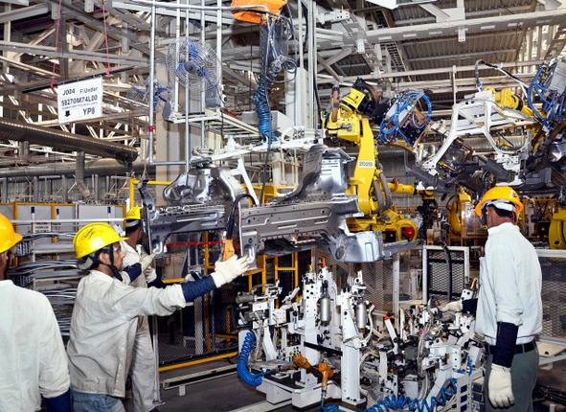Inspecting manufacturing facilities to assess and improve performance
* Working with buyers and project managers to maintain a steady flow of supplies
* Developing specifications for the design and manufacturing of various pieces of equipment
* Evaluating work samples to ensure design and functionality standards are met

Most production engineers work full time in office settings, although in some instances, professionals need to travel to manufacturing facilities to ensure manufacturing specifications and activities are being followed.